Module: Robotics

Topic Area: Circuits

Benchmark/Lesson: SC.B.1.2-1/2; SC.B.1.2-4/5; SC.C.2.2.1– Electric Circuits
SC.B.1.2/1; SC.C.2.2/1; SC.C.2.2/3 – Electric Motor Schematics
SC.B.1.2.5 /SC.C.1.2/1; SC.C.2.2-1/3 – Robotics Schematics
________________________________________________________________________

Lesson 1: Electric Circuit Schematics

Objective

The purpose of this lesson is to encourage students to recognize electric or circuit symbols. The students should be able to draw, understand and recognized parallel, series circuit and series-parallel circuits using electrical diagram. They will discover the differences between all the previous circuits. In addition they will learn how to classify the resistor by colors and resistance using the table provides by the teacher. If time permits, they are going to be able to built different circuit example an alarm, magnetic sensors, etc…

Lesson Background

The components built into an electrical circuit determine how electrical current and voltage are used to make an electrical or electronic equipment to work. An electrical device that provides a path for an electric current to flow is called an electrical circuit. The voltage on the other hand measures the difference in electrical charge between to points in an electrical circuit. The electric current is defined as a flow of electric charges in any electrical conductor. But one of the question that need to be answer is, what does an electric current need in order to flow? A conductor is a material that current can pass through easily. The others material that cannot pass current are name insulators. Some materials cut down the flow of current, these types of devices are name resistors.
All the circuit requires the same basic components, power source (battery, alternator, generator, etc), protection devices (fuse, circuit breaker), loads device (lamp, motor, winding, and resistor), control device (switch, relay or transistor) and conductors (wire, or return path).

Math Skills
Measurement
Addition and multiplication
Data analysis

Science Skills
Forming a question
Hypothesizing
Communicating
Observing
Recognizing variables
Collecting data
Inferring
Predicting outcome
Interpreting data
Correlating data

Engaging Question

- What is an electrical current?
- What is an electrical circuit?
- Describe in your own words the basic components that are require to build a circuit?
- What does a resistor do in a circuit?
- What type of instrument is required to measure the voltage of a circuit?

Students Pre-Lab Activity (two pre-lab activities are suggested, teacher may choose one or both)

- The first activity consists in an Electric Circuit Symbols Match according his use or definition. The teacher has to define all the basic electric circuit symbols and each function before the student continue with the matching activity.
- The second activity consists of a Resistance Color Calculation using the Resistor Color Code Chart. The teacher has to explain and offer some examples before the students carry on this activity.

Pre-Lab Activity 1 “Electric Circuit Symbols Match”

Name: _____________________ Date: _____________________
Instructions: Match the actual concepts with the letters that represent the schematic symbols of electric circuits’ diagrams.

___1. Used to measure Voltage

___ 2. Ohmmeter | 
___ 3. Supplies electrical energy | 
___ 4. Resistor | 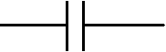
___ 5. Lamp | 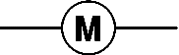
___ 6. Converts electrical energy to sound | 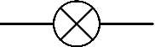
___ 7. Capacitor

___ 8.Diode | 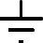
___ 9. Receive or transmit radio signal. | 
___ 10. Fuse | 
___ 11. Connection to Earth.

___ 12. Bell | 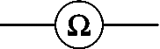
___ 13. Transformer | 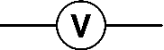
___ 14. Motor | 
___ 15.On-Off Switch | 

Pre-Lab activity 2 Resistor Color Code

Resistor values are coded with colored bands painted onto the shell of the resistor. To read the value of the resistor, you need to know what the colored bands mean, and you need to know from which end to start reading.

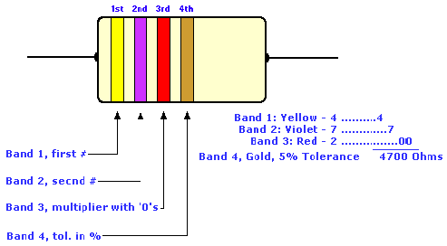

Figure 1: Graphical representation of a resistor

Resistor Color Code Chart

Table 1 |  | Table 2 |  | Table 3
Integer Value |  | Multiplier Value |  | Tolerance Value
Black | 0 | Black | 1 | Gold | ±5%
Brown | 1 | Brown | 10 | Silver | ±10%
Red | 2 | Red | 100 | None | ±20%
Orange | 3 | Orange | 1000
Yellow | 4 | Yellow | 10000
Green | 5 | Green | 100000
Blue | 6 | Blue | 1E+06
Violet | 7 | Gold | 0.1
Gray | 8 | Silver | 0.01
White | 9

Reading the Color Bands

- Look at the first color band from the left and ascertain its color.
- Find the color in Table 1 and write down the corresponding number.
- Look at the second color band from the left and ascertain its color.
- Find the color in Table 1 and write down the corresponding number immediately following the first number you wrote down.
- Look at the third color band from the left and ascertain its color.
- Find the color in Table 2 and write down the corresponding multiplier digits, preceded by a multiplication symbol (x).

Calculating Resistance Value

- Consider the first two digits (from Table 1) as one integer.
- Multiply the integer by the multiplier (from Table 2).
3. Use Table 3 to determine the tolerance on the resistor.

Name _________________________ Date________________________

Determine the Resistance using the Resistor Color Code Chart

Instructions: Following the previous rules to determine the values for each resistance.

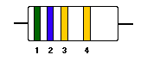  1st band: ______  2nd band: ______  3rd band: ______  4th band, tolerance in %: ______  Answer:_____________ | 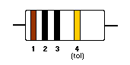  1st band: ______  2nd band: ______  3rd band: ______  4th band, tolerance in %: ______  Answer:_____________
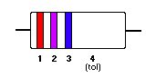  1st band: ______  2nd band: ______  3rd band: ______  4th band, tolerance in %: ______  Answer:_____________ | 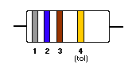  1st band: ______  2nd band: ______  3rd band: ______  4th band, tolerance in %: ______  Answer:_____________
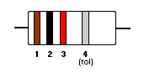  1st band: ______  2nd band: ______  3rd band: ______  4th band, tolerance in %: ______  Answer:______________ | 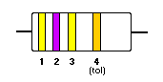  1st band: ______  2nd band: ______  3rd band: ______  4th band, tolerance in %: ______  Answer:_____________
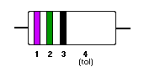  1st band: ______  2nd band: ______  3rd band: ______  4th band, tolerance in %: ______  Answer:______________ | 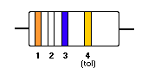  1st band: ______  2nd band: ______  3rd band: ______  4th band, tolerance in %: ______  Answer:_____________
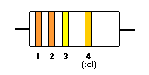  1st band: ______  2nd band: ______  3rd band: ______  4th band, tolerance in %: ______  Answer:_______________ | 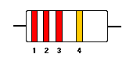  1st band: ______  2nd band: ______  3rd band: ______  4th band, tolerance in %: ______  Answer:_____________

Parallel, Series and Series-parallel Circuits Laboratory Background

What is Ohm’s Law?
Ohm's Law says: The electric current in a circuit is directly proportional to the applied voltage and inversely proportional to the amount of resistance. This means that if the voltage goes up, the current flow will go up, and vice versa. Also, as the resistance goes up, the current goes down, and vice versa. Ohm's Law can be put to good use in electrical troubleshooting. Mathematical formulas can be difficult for many who don't use them regularly. Most people can remember a picture easier than a mathematical formula. By using the Ohms law symbol below, anyone can remember the correct formula to use. By knowing any two values you can figure out the third. Simply put your finger over the portion of the symbol you are trying to figure out and you have your formula.
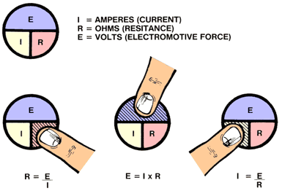
Students should be aware of the importance of an electric circuit, especially in their everyday life. However, the circuits that they experimented with are not quite the same circuits that they use in their home. When you use a toaster, vacuum cleaner or other electrical appliance in your home you are using current electricity. Why is it that certain appliances can be turned off, while others keep on running? Does turning on one appliance affect the current or potential difference in another appliance? The answer lies way that circuits are put together. Although these circuits are complicated we must keep in mind that complex circuits are simply combinations of series and parallel connections.
SERIES CIRCUITS
A Series Circuit has only one path to ground, so electrons must go through each component to get back to ground. All loads are placed in series.
Therefore:
1. An open in the circuit will disable the entire circuit.
2. The voltage divides (shared) between the loads.
3. The current flow is the same throughout the circuit.
4. The resistance of each load can be different.
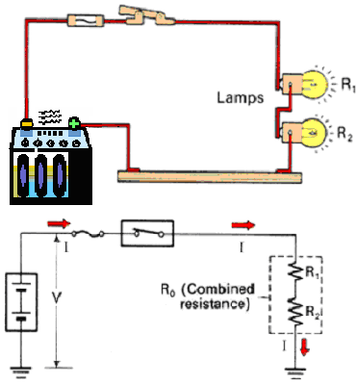
PARALLEL CIRCUITS

A parallel circuit is a closed circuit in which the current divides into two or more paths before recombining to complete the circuit. This type of connection keeps the same voltage across each resistor. If the resistors have different resistance values, they will carry different amounts of current, each in accordance with Ohm's Law.
A parallel circuit is designed so that if one branch is defective, the flow of electricity will not be broken to the other branches.
A Parallel Circuit has multiple paths or branches to ground.
Therefore:
1. In the event of an open in the circuit in one of the branches, current will continue to flow through the remaining.
2. Each branch receives source voltage.
3. Current flow through each branch can be different.
4. The resistance of each branch can be different.

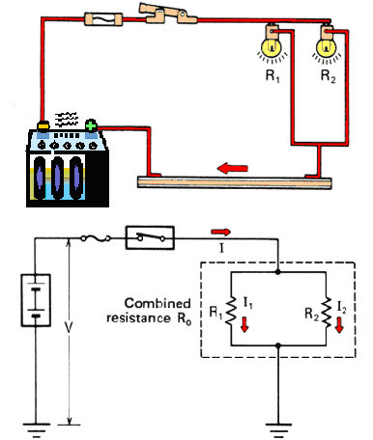

SERIES-PARALLEL CIRCUIT
A resistance and lamps may be connected in a circuit as illustrated below. This type of connecting method is called series-parallel connection, and is a combination of series and parallel connections. The car interior dash board lights are a good example. By adjusting the rheostat, you can increase or decrease the brilliance of the lights.
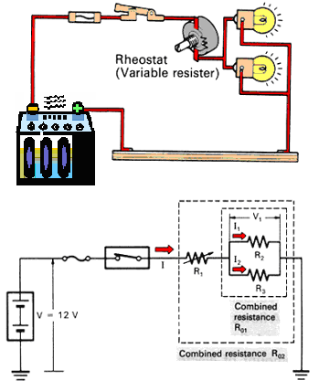
The combined resistance R02 in this series-parallel connection can be determined in the following order:
a. Determine combined resistance R01, which is a combination of resistances R2 and R3 connected in parallel.
b. Then, determine resistance R02, which is a combination of resistance R1 and combined resistance R01 connected in series.

Teacher’s Procedure
  - The day prior to starting the activity has the students do a pre-lab engaging question and one of the pre-lab activities. {Consider: (1) Allowing the students take it home for homework and include a section for parental involvement.
  - Checks to make sure students have done the pre-lab, allow students to keep the pre-lab until they have completed the experiment and drawn conclusions.
  - Take 10-15 minutes to review each lecture on “Electrical Circuit Symbols” and “Resistance Color Code Chart”.
  - Explain in detail the activity. As you explain the activity point out each piece of material.
How to manage the experiment

- Place the students in group of 4 to 5.
- Have all materials in a centrally area and have one person from each group gather the needed material for his/her group.
- Assign different circuits (parallel, series and parallel-series) to each group.
- Provide the data sheet attached to the experiment.
- Walk around the room and provide assistance when it is needed. Check to make sure that the connections and wires are hooked up in a parallel or series circuit. Check to see that each group experiments with all types of circuits. Provide plenty time for the students to set up and explore with their models (approximately 45 minutes).
- Notify to the student when it is time to pick up and have each group return their materials in an organized fashion to the back of the room.
- Some children will need help to actually hook the wires to the battery, switch, and lights. I recommend alligator clips for those children who have physical disabilities with their hands. Have your resource teacher help you but give them advance warning that you will need their assistance this day.

Materials

- Electric Circuit kit
- 2 light bulbs
- Multi-meter for voltage and current
- 1 iron spring
- 2 alligator clips
- 2 piece of wire
- Switch
- 2 to 4 batteries

Student Procedure
Students group will begin the experiment with their corresponding circuit diagram. They will follow the teacher instruction all the time.
- Using the battery, switch, alligator clips, lamp holders, and lamps, erect a series circuit as in the diagram below. The more bulbs you put on the series circuit, the more voltage you will need.
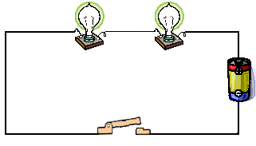

Switch
Series Circuit
Battery

- Using the ammeter, find the current (A) at two different places in the circuit. Record your data in the table.
- Using the voltmeter, find the voltage across each bulb. Record your data in the table.
- While you re still connected to the source, unscrew one of the bulbs and see what happens. Record your observations in the table.
- Using the battery, switch, alligator clips, lamp holders, and lamps, erect a parallel circuit as in the diagram below.
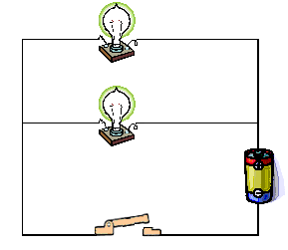

Switch
Parallel Circuit

Battery
Junction
Junction
-

+
- Using the ammeter, find the current (A) at two different places indicate on the circuit diagram. Record your data in the table.
- Using the voltmeter, find the voltage across each bulb. Record your data in the table.
- While you re still connected to the source, unscrew one of the bulbs and see what happens. Record your observations in the table.
- Using the battery, switch, alligator clips, lamp holders, and lamps, erect a series-parallel circuit as in the diagram below.
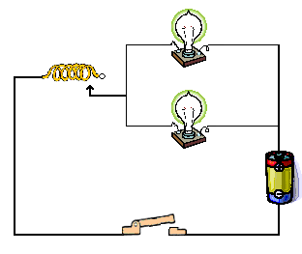

Junction
Junction
Battery

Rheostat

Switch
Series-parallel Circuit
- Using the ammeter, find the current (A) at two different places indicate on the circuit diagram. Record your data in the table.
- Using the voltmeter, find the voltage across each bulb. Record your data in the table.
- While you re still connected to the source, unscrew one of the bulbs and see what happens. Record your observations in the table.

Note: Go over the difference between the circuits. Points out that the lights get dimmer on a series circuit; in the other hand the lights are all illuminated the same on a parallel circuit.

Scientist Work Sheet

Name: ________________________ Date: _________________________

- Experimental Data Sheet

Circuit Type | Current at Position #1 (Amp) | Current at Position #2 (Amp) | Voltage at bulb #1  (Volts) | Voltage at bulb #2 (Volts) | Unscrew bulb remarks
Series
Parallel
Circuit Type | Current at Position #1 (Amp) | Current at Position #2 (Amp) | Voltage at bulb #1  (Volts) | Voltage at bulb #2 (Volts) | Rheostat connection remarks
Series-parallel

- Questions 1-3 pertain to the series circuit:

1. How did the current compare at the specify points in the circuit?
________________________________________________________________________________________________________________________________________________________________________________________________________________________

2. What is the voltage of your source? Plus use your diagram to explain why it is named a series circuit.
________________________________________________________________________
________________________________________________________________________

3. a) Write a statement to describe the current across each bulb.
________________________________________________________________________________________________________________________________________________________________________________________________________________________

b) How does the voltage across each bulb, compare to the voltage of your source?
________________________________________________________________________________________________________________________________________________________________________________________________________________________
- Questions 4-6 pertain to the parallel circuit:
4. How did the current compare at the specify points in the circuit?
________________________________________________________________________________________________________________________________________________
________________________________________________________________________

5. What is the voltage of your source? Plus use your diagram to explain why it is named a parallel circuit.
________________________________________________________________________________________________________________________________________________

6. a) Write a statement to describe the current across each bulb.
________________________________________________________________________________________________________________________________________________________________________________________________________________________

b) How does the voltage across each bulb, compare to the voltage of your source?
__________________________________________________________________________________________________________________
_________________________________________________________
- Questions 7-9 pertain to the series-parallel circuit:
7. How did the current compare at the specify points in the circuit?
________________________________________________________________________________________________________________________________________________________________________________________________________________________

8. What is the voltage of your source? Plus use your diagram to explain why it is named a series-parallel circuit.
________________________________________________________________________________________________________________________________________________

9. a) Write a statement to describe the current across each bulb.
________________________________________________________________________________________________________________________________________________________________________________________________________________________

b) How does the voltage across each bulb, compare to the voltage of your source?
__________________________________________________________________________________________________________________
_________________________________________________________

- Conclusion:
Fill in the blanks on the basis of your observations and analyses.
- In a series circuit the current is the ________ everywhere in that circuit.
- In a series circuit if one bulb is removed, all the bulbs go _______.
- In a series circuit the _________ is divided among all the resistances (bulbs) in the circuit.

- In a parallel circuit the current is _________ the same everywhere in that circuit. It will split up and take the easiest electrical path.
- In a parallel circuit if one bulb is removed, the rest will stay ________.
- In a parallel circuit the voltage across each bulb is the _________.
- In a series-parallel the current is ________everywhere in that circuit.
- In a series-parallel circuit if the rheostat is removed, the rest will stay ________.
- In a series-parallel circuit the voltage across each bulb is _________.
- In a series-parallel circuit if one bulb is removed, the rest will stay ________.

Student Post Lab Activity

Drawing Conclusion/Discussion Questions
- Review and discuss what the groups discovered on their own about parallel, series and parallel-series circuits. Re-examine any areas of confusion and make sure that the students understand clearly about each type of circuit. Also, review the different parts of the diagram and what each symbol represents.
- In order to assess students' understanding on an individual basis, have students work independently on a homework assignment. These questions include:

    - In what type of circuit is there only one path through which the charges can flow?

    - In a series circuit, what happens when the first bulb is unfastened?
    - What happens when the second bulb is unfastened (and the first one is re-fastened)?

    - Why are both types of circuits useful in our lives?
    - Draw a diagram for each one of the circuit study in class?
    - In what type of circuit is there more than one path through which the charges can flow?

    - In a parallel circuit, what happens when the first bulb is unfastened?
    - What happens when the second bulb is unfastened (again with the first one reconnected)?

    - Why simple circuits might not be appropriate in their house? Give them clues.

    - How do you think the lights in your house are configured? Explain your answer.

    - Are the appliances all on the same wire? If they are, what happens when one is turned off? Is the circuit broken? If it is broken, will a circuit work?

    - Why are the circuits in buildings usually parallel circuits? Give them clues.

    - Compare a parallel with a series circuit. In which circuit did the two light bulbs appear brighter?
    - Why is it important that connections in a circuit be tight?
    - Why do you have to close the switch? Explain your answer
Interdisciplinary Activities (activity involving these subjects)
- Language Arts
The students will be requires to develop a report explaining the different steps they took all over the experiment.
- Math
- Multiplication skills
- Current and Volt Measurement using a multi-meter.
- Data analysis
- Critical Thinking
- Answer of multiple question base on observation, deduction and understanding.
- Writing a report about the previous experimental lesson is suggested. Students could consult the some books at the library and use the internet as a source.

References/Suggested Sources/Websites

- http://www.play-hookey.com/dc_theory/parallel_resistors.html
- Harcourt Science Unit E “Physical Science” 1st edition, Harcourt School Publishers, Orlando, Boston, Chicago, San Diego
- http://www.msnucleus.org/membership/html/k-6/as/technology/4/ast4_3a.html
- http://www.ndt-ed.org/EducationResources/seriesparallelcircuits.htm
- http://www.energyquest.ca.gov/projects/rheostat.html

